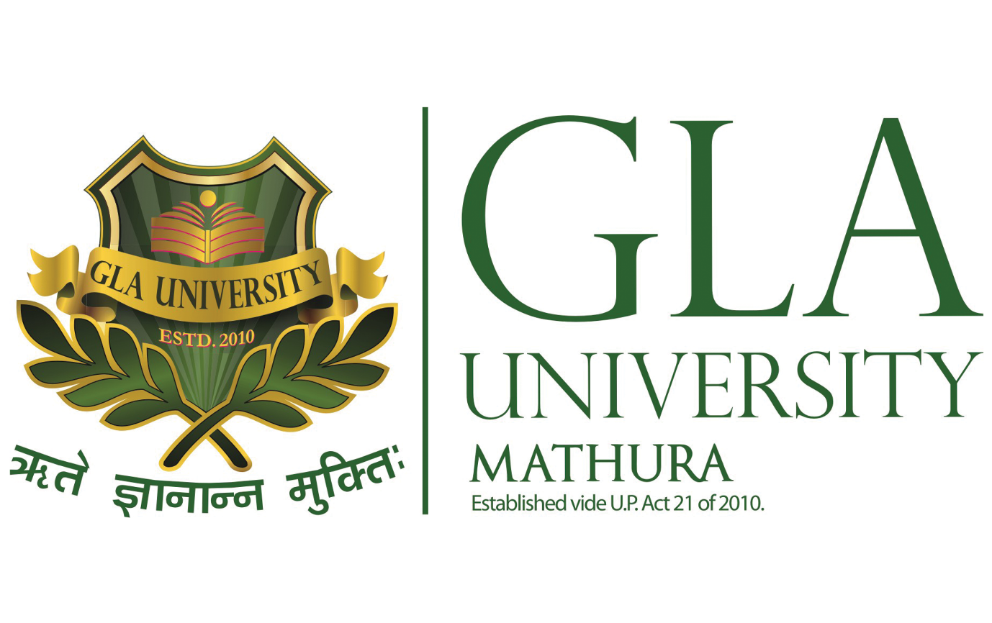

**MINOR PROJECT- II**

**SYNOPSIS**

**Social Media App**

**Submitted by: Submitted to:**

Ayush Tiwari (201500184) Mr. Manoj varshney

Shubhi Gupta (201500683)

Vibhu Rathore (201500780)

Vinay Tomar (201500787)

**Declaration**

We hereby declare that the project work entitled “*Social Media App*” submitted to the GLA University, is a record of an original work done by us groupmates under the guidance of *Mr. Manoj Varshney*, and this project work is submitted in the partial fulfilment of the requirements for the award of the degree of Bachelor of Technology in Computer Science & Engineering. The results embodied in this thesis have not been submitted to any other University or Institute for the award of any degree or diploma.

**Acknowledgment**

It gives us a great sense of pleasure to present the synopsis of the BTech minor project undertaken during the B.Tech III Year. This project is going to be an acknowledgment of the inspiration, drive, and technical assistance that will be contributed to it by many individuals.

We owe a special debt of gratitude to *Mr. Manoj Varshney, Technical Trainer*, for providing us with an encouraging platform to develop this project, which thus helped us in shaping our abilities towards a constructive goal, and for *his* constant support and guidance to our work. *His* sincerity, thoroughness, and perseverance have been a constant source of inspiration for us. We believe that *he* will shower us with all his extensively experienced ideas and insightful comments at different stages of the project & also teach us about the latest industry-oriented technologies.

We also do not like miss the opportunity to acknowledge the contribution of all faculty members of the department for their kind guidance and cooperation.

*Ayush Tiwari*

*(201500184)*

*Shubhi Gupta*

*(201500683)*

*Vibhu Rathore*

*(201500780)*

*Vinay Tomar*

*(201500787)*

**Contents**

1. **Introduction**
   1. **Objective**
   2. **Scope of the project**
   3. **Problem Statement**
2. **Software Requirement**
   1. **Hardware Requirements**
   2. **Software Requirements**
3. **Project Description**
4. **Working**
5. **Implementation**
6. **Reference**

**Introduction**

Social Media is not simply an important tool for communication, connecting people locally and globally, it also lets people to share, create, and spread information. These platforms also cast an immense influence on consumer’s purchase habits and decisions through their product reviews, marketing tactics and advertising algorithms. Businesses utilize social media to interact with their target market, build brand awareness, create leads, increase sales, and make money. Businesses may effectively target their advertising because to social networks’ exclusive access to members’ most sensitive information, including their interests, hobbies, and frequented areas. It allows companies to not only engage with the customers on a personal level but also influence them with the appropriate content, triggering desire and formulating purchase patterns.

Here we develop a fully functional and user-friendly social platform that does not include any of the business models or customised advertising. It can be used as a tool for various studies on Influence, social network formations, homophile and much more in an unaltered, content controlled environment.

**Objective**

MERN Stack is a web development framework that uses MongoDB, ExpressJS, ReactJS and NodeJS as its four main technologies. Performance is much more important now because of the explosive growth in the number of electronic devices with real-time and Internet capabilities. Consequently, the web development sector has experienced rapid expansion. The most popular web development frameworks over the past few years have been based on conventional technologies like Servlets, ASP.NET, and PHP. The performance expectations of today’s consumers are not met by these technologies, despite their widespread use and lengthy histories of research and deployment. Recently, the MERN stack was developed because of its consistency and simplicity to address this performance issue.

The four technologies employed here in MERN stack are all Javascript based in addition to being high-performance and customizable. Therefore, the backend, frontend, and database can be controlled easily if one knows JavaScript (and JSON), which makes the technology a very popular choice. The goal here is to utilize the fore-mentioned technologies to design and implement a fully functional, user-friendly social platform. This web application will not only demonstrate the deployment of these tools but will also provide as a gizmo for further research along the lines of network formation, online behaviour, social influence and much more

**Scope of the Project**

Social Media is an ever growing industry. Information is more valuable than gold. Uncountable tools ranging from NLP, Sentiment Analysis, decrypting patterns, Big Data analysis, micro and macro network studies, human behaviour, impact of influence, triggering heard behaviour and much, much more has branched out ever since the rise of Social Media. The future scope of this particular project has no bounds but restricting our focus towards the short term goals and for better implementation of this project, I would like to work on improving the UI and towards the functionalities this application is offering. It is the first step to build any successful web app. If the User Experience is not rich enough, it will never gain that many participants in order to conduct these further ”behind-the-scenes and under-the-hood” studies. As for the long term goals, who’s to say, maybe someday we find a way to use the networks to detach people from consumerism instead and to promote and influence more pressing problems as we now know the power Social Media possesses.

**Problem Statement**

In today's digital age, social media platforms have become an integral part of our lives. However, most social media platforms are owned by a few large corporations, which limits user control and privacy. In addition, users often have to switch between multiple apps to perform different tasks, such as messaging, posting updates, and sharing photos.

To address these issues, we propose to develop a social media app using the MERN (MongoDB, Express, React, Node.js) stack. The app will be designed to provide users with a single platform for all their social media needs. It will allow users to create and manage their profiles, post updates, share photos and videos, follow other users, and chat with their friends.

The app will be designed with a focus on user privacy and control. Users will have the option to control who sees their posts and to delete their data from the app at any time. Additionally, the app will be built with security in mind, with robust authentication and authorization mechanisms to protect user data.

The app will be developed using agile methodologies, with regular user feedback and testing to ensure that it meets the needs of its users. The end product will be a user-friendly, feature-rich social media platform that offers users complete control over their data and privacy.

**HARDWARE SPECIFICATIONS:**

* Processor: i3/Intel or Above
* Processor RAM: 8GB (min)
* Hard Disk: 128 GB(min)
* Key Board: Standard
* Mouse: Any
* Monitor: Any

**SOFTWARE  SPECIFICATIONS:**

* Operating System: Windows 7+
* Server-side Script: JavaScript
* IDE: VsCode

**Project Description**

The MERN (MongoDB, Express, React, Node.js) stack social media app is a platform for users to connect and share content with one another. The app will allow users to create an account, log in, post content (text, images, and videos), view content posted by other users, and interact with other users' posts by liking, commenting, and sharing.

The app will include a homepage where users can view a feed of posts from other users. The homepage will be updated in real-time, showing the latest posts at the top of the feed. Users can also search for specific posts or users using a search bar.

The app will have user profiles where users can view their own posts, as well as their followers and following. Users can also edit their profile information and profile picture.

The app will have a notification system that alerts users when someone interacts with their posts or follows them. Users will also receive notifications for system-generated messages, such as password reset requests.

The app will include an admin panel that will allow the app administrators to manage the user base, including deleting and blocking users if necessary.

The MERN stack social media app will be built using modern web development tools and best practices. The front-end will be built using React.js, while the back-end will be built using Node.js and Express. The app will use MongoDB as the database to store user data and content.

Overall, the MERN stack social media app will provide a user-friendly and engaging platform for users to connect and share content with one another.

.

**Working**

A MERN stack social media app would be a web application built using the MERN (MongoDB, Express.js, React.js, and Node.js) stack. The app would allow users to create profiles, share posts, comment on and like posts, and connect with other users.

The app would have a front-end built using React.js, which would handle the user interface and user experience. The React.js framework would enable the app to be responsive and interactive, ensuring a seamless experience for the user.

The back-end would be built using Node.js and Express.js, which would handle the server-side logic and routing. The app would use MongoDB, a NoSQL database, to store user data such as profiles, posts, and comments.

Some of the key features of the app could include:

1) User Authentication: The app would allow users to sign up and log in using their email address, phone number, or social media accounts. User authentication would be implemented using JSON Web Tokens (JWT) and bcrypt for password hashing.

2) User Profiles: Users would be able to create and customize their profiles with personal information, profile pictures, and cover photos.

3) Post Sharing: Users would be able to create and share posts with text, images, and videos. They would also be able to edit and delete their posts.

4) Social Interactions: Users would be able to interact with posts by liking, commenting, and sharing them. They could also follow other users and receive notifications when they post something new.

5) Search Functionality: Users would be able to search for other users, posts, and hashtags.

6) Security: The app would implement security measures such as input validation, CSRF protection, and rate limiting to prevent attacks such as cross-site scripting (XSS), cross-site request forgery (CSRF), and denial-of-service (DoS).

Overall, a MERN stack social media app would provide users with a platform to connect with others, share their thoughts and ideas, and build a community around shared interests.

**Implementation**

To implement a MERN stack social media app, you would need to follow these steps:

* 1. Set up the Development Environment: Install Node.js, MongoDB, and a code editor of your choice on your local machine.
  2. Create a New React App: Use the create-react-app command to create a new React app.
  3. Set up the Back-end: Create a new folder for the server-side code and initialize it as a Node.js project using npm init. Install the necessary packages like express, mongoose, and bcrypt.
  4. Set up the Database: Connect to the MongoDB database using Mongoose and create the necessary models for users, posts, and comments.
  5. Implement User Authentication: Use JSON Web Tokens (JWT) and bcrypt to implement user authentication and password hashing.
  6. Create User Profiles: Implement the ability for users to create and customize their profiles with personal information, profile pictures, and cover photos.
  7. Implement Post Sharing: Allow users to create and share posts with text, images, and videos. Implement features like editing and deleting posts.
  8. Implement Social Interactions: Allow users to interact with posts by liking, commenting, and sharing them. Implement features like following other users and receiving notifications when they post something new.
  9. Implement Search Functionality: Allow users to search for other users, posts, and hashtags.
  10. Implement Security Measures: Implement security measures such as input validation, CSRF protection, and rate limiting to prevent attacks such as cross-site scripting (XSS), cross-site request forgery (CSRF), and denial-of-service (DoS).
  11. Test and Deploy: Test the app thoroughly and deploy it to a hosting service like Heroku or AWS.

Overall, building a MERN stack social media app requires a solid understanding of web development concepts and the technologies involved in the MERN stack. It can be a complex project, but with careful planning and implementation, you can create a robust and scalable social media app.

**Flowchart**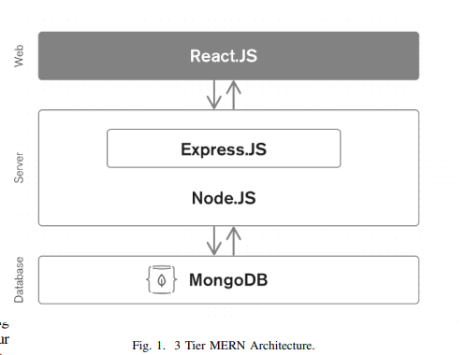

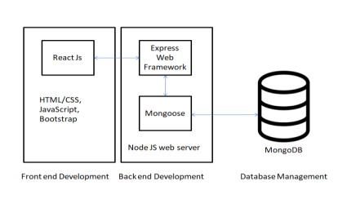

**References**

[1] https://annalsofrscb.ro/index.php/journal/article/view /6683/5035

[2] https://www.irjet.net/archives/V5/i2/IRJET-V5I2397

[3] https://www.academia.edu/68509443/A_Review_on_T echnologies_used_in_MERN_stack

[4] https://www.theseus.fi/bitstream/handle/10024/5021 10/Cuong_Cao_Nguyen.pdf?sequence=2

[5] IEEE.Dyl, T. and Przeorski, K., 2017. Mastering FullStack React Web Development. PacktPublishin

**Faculty Guidelines**

*Mr. Manoj Varshney*

*(Technical Tranier, GLA University, Mathura)*

**GitHub Repository Link**